Bihar & Jharkhand Medical Assoc. (UK)
  - 41 Annual Congress – 11 & 12 July 2020
Patrons:
Dr. Kaladhar Jha
Dr. Anjani Kumar
Dr. Arun Mishra
Dr. S.K. Singh

Organising Secretaries:
Dr. Smiti Das
Dr. Jai Prakash Narain

Executive Directors:
Dr. Sanjay Arya
Dr. Poonam Jha
Dr. Raj Morijawala
Dr. Ganesh Sarin
Dr. Rakesh Singh

Treasurer:
Dr. Sanjeev Prasad

Scientific Committee:
Dr. Pravin Jha
Dr. Radhika Prasad
Dr. Rajeev Singh
Dr. Rakesh Sinha

Entertainment Committee:
Dr. Aishwarya Lant
Dr. R.R. Das
Dr. Krishna Kanhaiya
Dr. Vibahash Mishra
Dr. Chitij Mohan
Dr. Deepa Prasad

Magazine & Souvenirs:
Dr. Akhoury A. Shanker
Dr. Manisha Singh

Cuisine:
Dr. Rambhadra Jha
Dr. Sushil Morijawala

Reception:
Dr. Jyoti Didwania
Dr. Mangla Dubey
Dr. Navya Roy
Dr. Abha Sinha
Dr. Shilpa Shekhar

Central Committee:
President:
Dr. Anand Prakash
Treasurer:
Dr. Prateek Akhoury
Secretary:
Dr. Amit Kishore
Lead Guest Name:

Address:

Telephone: Email:

Tickets required (see below for pricing):

Ticket Type | Quantity | Cost (cross as applicable) |  | Total
Adult |  |  | £90 / £110
Child |  |  | £50 / £60
Total |  |  | -

Guest Details:
Name

Ticket Pricing:

Registration | Age 5 & Below | Ages 5 to 14 | Ages 14+
Until 31 May 2020 | Free | £50 | £90
From 1 June 2020 | Free | £60 | £110

Cancellation Policy: 50% refund until 31 May 2020 and no refunds thereafter.
Payment details overleaf.

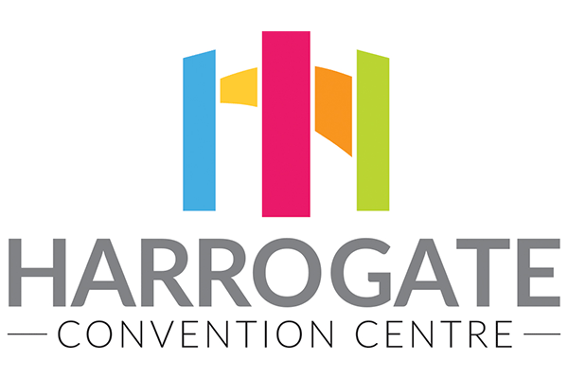

Correspondence: Venue:
bjma_2020@outlook.com Harrogate Convention Centre

47 Bogs Lane Kings Road
Harrogate Harrogate
HG1 4EB HG1 5LA

07780695220 harrogateconventioncentre.co.uk

Kindly complete the form & enclose the payment at your earliest convenience. This will enable the committee members to work seamlessly and organise with less stress! If you are paying by online bank transfer, it is still mandatory to compete and return the registration form.

Payment can be made by cheque, payable to ‘BJMA 2020’ or via bank transfer (BACS):
A/C name: BJMA 2020. Sort code: 20-98-98 A/C no. 23610209.
Please put your details in the reference section of the bank detail.

Please return the form to: Dr. Smiti Das & Dr. Jai Prakash Narain (Organising Secretaries),
Tel: 01423 548142 Mob: 07780695220 E-mail: bjma_2020@outlook.com

Please do not hesitate to contact Smiti or JP on the details above if you have any queries or require further information.
Best wishes for the New Year and we look forward to seeing you all on the 11th & 12th July 2020 at the Harrogate Convention Centre.

Smiti & JP

